PRODUCTS TO BUY

- Primacy 2 duplex printer: Rs 50,000
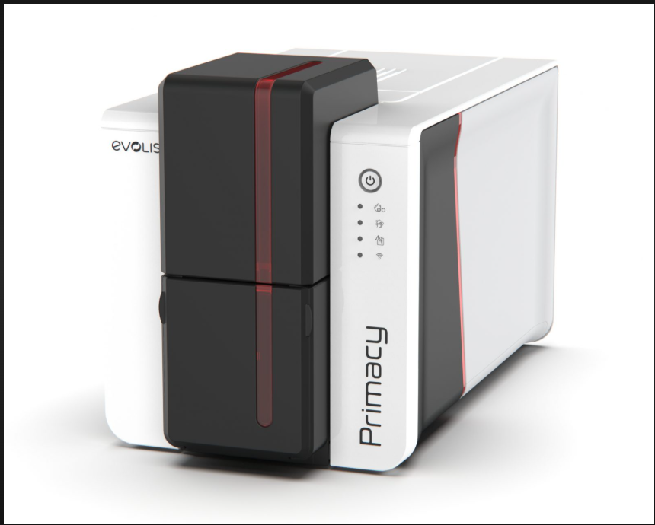
- Color YMCKO 300 PRINTS/ROLL : Rs 3600
- Upgrade cardpresso XXS to XS License Key : Rs 9500.
- Plain white PVC Card : 1500.
Total cost 64,600 + 11,628(Plus 18% GST)
TOTAL:76,228.
- Kyocera TASKalfa 2321 Monochrome Multifunction Printer.Rs 55000.
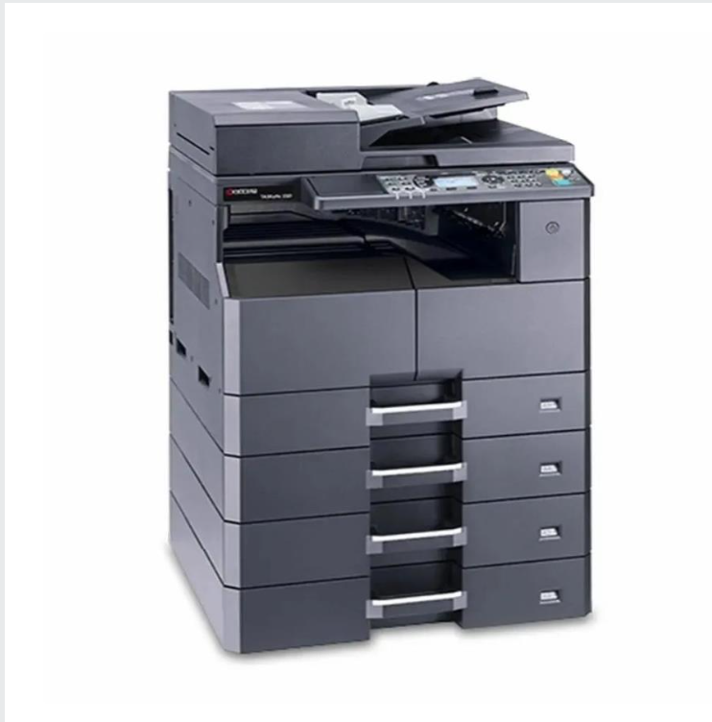

- Canon PIXMA MegaTank G3770 :18,000
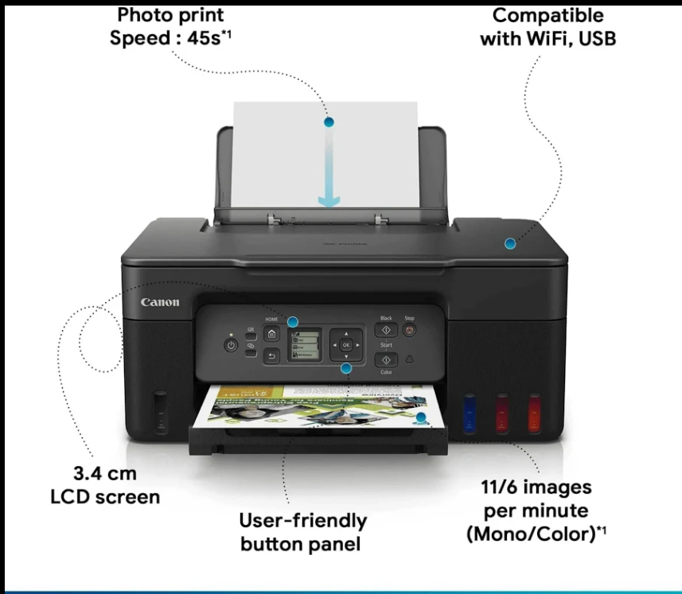
- Camera : 30,000.
- Lamination machine: 5000.
- Other Things :
- 1. A4 Plain Paper (75–80 GSM) 1700
- Kodak Premium Glossy A4 230 GSM (20 Sheets) 160
- Canon GI-71 Pack of 4 Ink Bottles 2700
- Custom printed lanyards: ₹15–₹35 each
- Transparent Card Holders Rs 4-10 ecah
- Laminating Pouches
ID Card Rs 250 – 400.
A4 Rs 600-1000.
- System :40,000
- Shop Advance : 50,000.
- Shop Rent :10,000
- Current bill: 4000/2month
- Wifi : Rs2000
- Photo Studio Items : 10, 000
- Interior :60,000.

